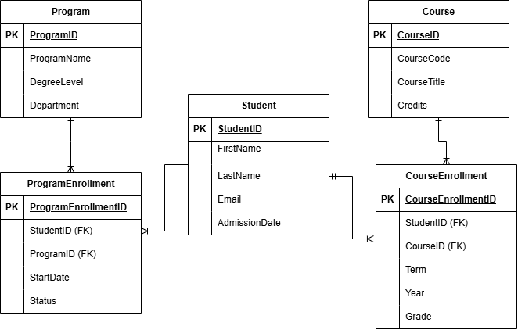

Relationships
One Student can have many ProgramEnrollment records, and one Program can have many ProgramEnrollment records. One Student can have many CourseEnrollment records, and one Course can have many CourseEnrollment records. ProgramEnrollment connects students and programs; CourseEnrollment connects students and courses. Each enrollment record belongs to exactly one student and one program or course. Grades in CourseEnrollment help track academic progress.

